Wanderlust Tours
Boutique journeys across Portugal and Andalusia

Founded 2014 Based in Lisbon, Portugal Office Rua das Flores 88, 1200-194 Lisbon Contact hello@wanderlusttours.example · +351 21 000 0000
We’re a small team of twelve, running a small number of trips. Every itinerary in this catalogue is one we walk ourselves — at least once a year, and usually more.

How our tours work
We’ve built the company around a simple idea: that the best way to see a place is to slow down inside it. Our groups are small, our pace is unhurried, and our guides live in the regions they show you.
Group sizes. Maximum of 12 travellers per tour. Some departures fill at 8.
What’s included. Accommodation in characterful three- and four-star hotels, all guided activities, transport between trip locations, and most meals — typically breakfast every day, plus three to four dinners per week with local wine.
What’s not included. Flights to and from your starting city, travel insurance (required — see Booking Policies), personal expenses, optional excursions, and lunches on free days.
Pace and difficulty. Each package is rated 1 to 3:
- Level 1 — gentle. Mostly city walking and short transfers. Suitable for most travellers.
- Level 2 — moderate. Some longer days, occasional uneven terrain, two to four hours of walking on active days.
- Level 3 — active. Daily hikes, real elevation, weather you’ll feel.
Ages. Most tours are 12+. Family-specific tours are noted in the package details. We don’t currently run dedicated youth or solo-only departures.
Solo travellers. Welcome on every tour. A single supplement applies for private rooms — see each package for the amount. We don’t pair strangers into shared rooms.

What we can help you with
This catalogue, and the assistant on our website, can help you with:
- Information about our tour packages — itineraries, what’s included, pricing, group sizes
- Departure dates and availability windows
- Questions about the destinations we cover (Portugal and southern Spain)
- Our policies — bookings, cancellations, deposits, group rates
- General questions about travelling with us

What we can’t help you with directly
- We don’t book flights. You’ll arrange your own travel to the trip’s starting city. We’re happy to suggest arrival timing.
- We can’t process payments through chat. Booking happens by email or phone, with a member of our team.
- We can’t guarantee visa eligibility. That depends on your nationality and current rules — please check with your consulate.
- We don’t have live weather or disruption updates. For current conditions on your trip dates, write to us directly.
- We don’t offer instant private-itinerary customisation. Bespoke trips are designed by hand by our team — please get in touch and we’ll start a conversation.
If you’re asking about something outside the above, our team is happy to help: hello@wanderlusttours.example or +351 21 000 0000.

The tours
We run seven core itineraries across four categories. They run between March and November; we don’t operate in winter.
Category | Tour | Duration | Difficulty
City breaks | Lisbon Essentials | 4 days | 1
City breaks | Porto & Douro Valley Explorer | 5 days | 1
Nature | Azores: São Miguel Hiker | 7 days | 3
Culture & food | Alentejo Wine Trail | 6 days | 2
Beach | Algarve Coast in 5 Days | 5 days | 1
Culture & history | Andalusia: Seville to Granada | 8 days | 2
Family | Sintra & Cascais Family Adventure | 4 days | 1

1 · Lisbon Essentials
4 days · Group of up to 12 · Difficulty 1 · From €890 per person

Lisbon — Alfama rooftops and the river Tagus at golden hour
A short, well-paced introduction to Lisbon — the neighbourhoods that locals love, the views the guidebooks miss, and an evening of fado in a room small enough to feel like an invitation.
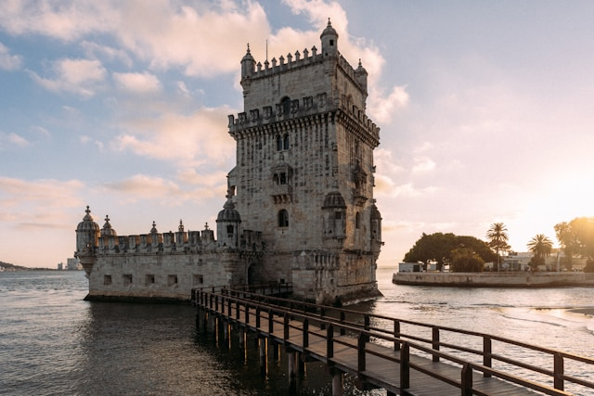
Belém Tower on the river — late afternoon light
Day by day
- Day 1 — Welcome dinner in Bairro Alto. Evening walking introduction to the old town.
- Day 2 — Alfama on foot with a local historian. Afternoon free. Optional pastéis de nata workshop in Belém.
- Day 3 — Day trip to Sintra: Quinta da Regaleira, Pena Palace, and a long lunch in the hills.
- Day 4 — Belém in the morning — the Tower, the Monastery, the Maritime Museum. Tour ends at 14:00.
What’s included. 3 nights’ accommodation in a small boutique hotel in Chiado, all guided activities, 2 dinners with wine, daily breakfast, all transport during the tour.
What’s not. Flights, lunches except where noted, optional pastéis workshop (€45).
Ideal for. First-time visitors to Portugal. Travellers with a long weekend.
Departures 2026. Mar, Apr, May, Jun, Sep, Oct, Nov.
Single supplement. €240.

2 · Porto & Douro Valley Explorer
5 days · Group of up to 12 · Difficulty 1 · From €1,290 per person
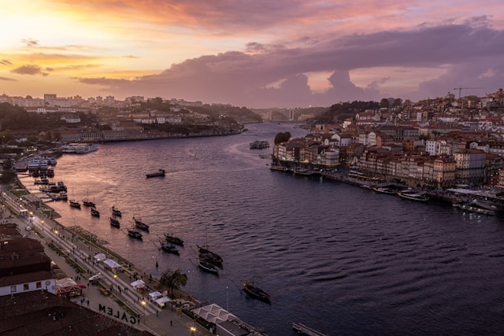
Porto — the Ribeira and the Douro river at twilight
Two nights in Porto’s working-port riverside, then three slow days in the Douro — two family wineries, a river cruise from Pinhão, and the kind of late lunches the valley was made for.
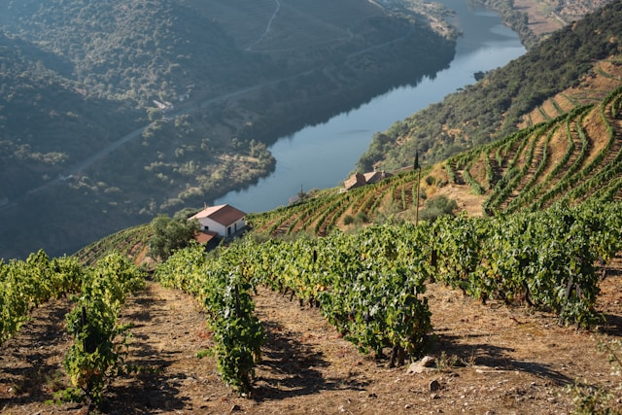
Douro Valley terraced vineyards from above
Day by day
- Day 1 — Arrive Porto. Welcome dinner at a long-running tasca in Ribeira.
- Day 2 — Morning walking tour of Porto: the Sé, Livraria Lello, Clérigos. Afternoon port cellar visit in Vila Nova de Gaia.
- Day 3 — Transfer to the Douro Valley. Lunch and tasting at our first winery, a fourth-generation quinta near Régua. Sunset on the terrace.
- Day 4 — Boat trip on the Douro from Pinhão. Lunch on the water. Afternoon visit to a smaller artisan producer.
- Day 5 — Slow morning at the quinta. Return to Porto. Tour ends at 17:00.
What’s included. 4 nights’ accommodation (2 in Porto, 2 at a Douro quinta), all guided activities, 3 dinners with wine, daily breakfast, all winery tastings, river cruise, all in-tour transport.
What’s not. Flights, 2 dinners on free evenings, additional wine purchases.
Ideal for. Wine enthusiasts. Travellers comfortable with two unhurried days in the same valley.
Departures 2026. Apr, May, Jun, Sep, Oct.
Single supplement. €320.

3 · Azores: São Miguel Hiker
7 days · Group of up to 10 · Difficulty 3 · From €1,890 per person
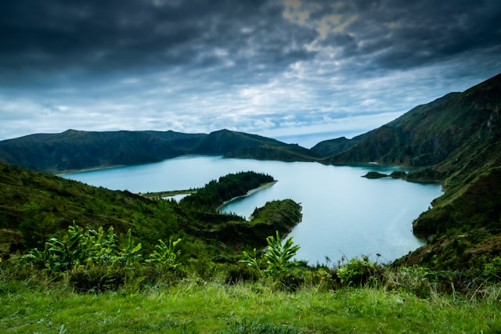
Sete Cidades — the twin crater lakes of São Miguel
A real walking tour. Crater rims, fern forests, a hot-spring valley, and one of the better whale-watching coasts in the North Atlantic. This is our most physical itinerary — expect four to six hours of walking on most days, sometimes in weather.
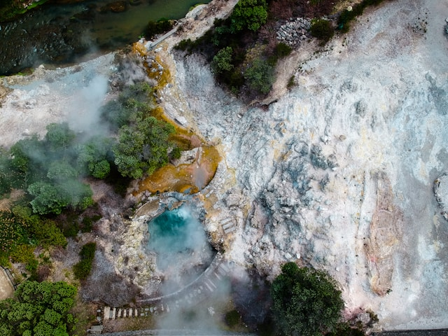
Furnas — geothermal valley steam vents and hot springs
Day by day
- Day 1 — Arrive Ponta Delgada. Easy orientation walk. Group dinner.
- Day 2 — Sete Cidades crater. Full-day rim walk (14 km, mostly gentle gradient, some exposure).
- Day 3 — Lagoa do Fogo. Descent into the crater, swim if conditions allow (10 km).
- Day 4 — Whale and dolphin watching by RIB from Ponta Delgada. Free afternoon.
- Day 5 — Furnas: thermal valley, geothermally-cooked cozido lunch, hot-spring soak in the afternoon.
- Day 6 — Eastern coast: Nordeste walk through ferns and laurisilva forest (12 km).
- Day 7 — Slow morning. Optional walk in the botanic garden. Tour ends at 13:00.
What’s included. 6 nights’ accommodation in small hotels and one family-run guesthouse, all guided walks, whale-watching excursion, 4 dinners with wine, daily breakfast, all in-tour transport, hiking-poles loan.
What’s not. Flights to Ponta Delgada, lunches except day 5, waterproofs (essential — bring your own).
Ideal for. Active walkers comfortable with full days on foot and changeable weather. Not suitable for travellers with mobility limitations.
Departures 2026. May, Jun, Sep.
Single supplement. €380.

4 · Alentejo Wine Trail
6 days · Group of up to 12 · Difficulty 2 · From €1,590 per person
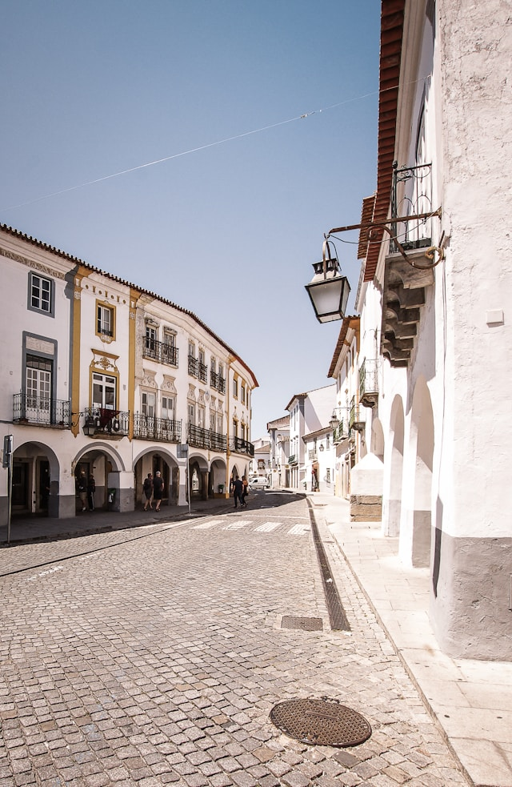
Alentejo — white-walled hill village with cork oak fields
The Alentejo is Portugal’s quietest landscape — cork oak forests, white-walled villages on hilltops, and a wine tradition that, until recently, was a local secret. This is a slow, deeply seasonal trip built around four wineries and the towns between them.
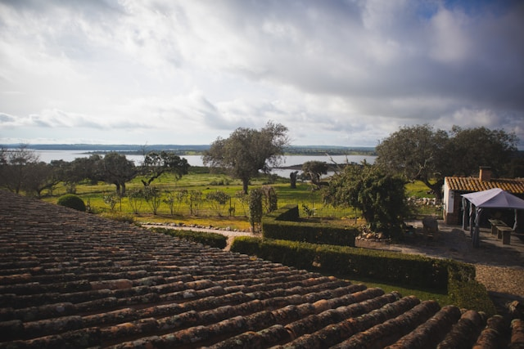
Vineyard rows at sunset in the Alentejo
Day by day
- Day 1 — Pickup from Lisbon. Drive to Évora. Walking tour of the old town: the Roman temple, the bone chapel, a long dinner.
- Day 2 — First winery: a small organic producer outside Évora. Tour, tasting, lunch in the vineyard.
- Day 3 — Drive to Monsaraz on the Spanish border. Free afternoon in the village. Sunset over the Alqueva lake.
- Day 4 — Second and third wineries — one traditional clay-amphora producer, one modern estate. Group dinner in a converted convent.
- Day 5 — Transfer to the cork country near Estremoz. Cork-oak forest walk with a local biologist (3 hours). Final winery and farewell dinner.
- Day 6 — Slow morning. Return to Lisbon. Tour ends at 15:00 in central Lisbon.
What’s included. 5 nights’ accommodation in restored country houses and a town hotel, all winery visits and tastings, 4 dinners with wine, daily breakfast, cork-forest walk, all transfers from/to Lisbon.
What’s not. Flights to Lisbon, 2 dinners on free evenings, additional wine purchases.
Ideal for. Wine enthusiasts who’d rather spend a week in one region than rush across three. Travellers who enjoy long, slow lunches.
Departures 2026. Apr, May, Sep, Oct.
Single supplement. €290.

5 · Algarve Coast in 5 Days
5 days · Group of up to 12 · Difficulty 1 · From €1,090 per person
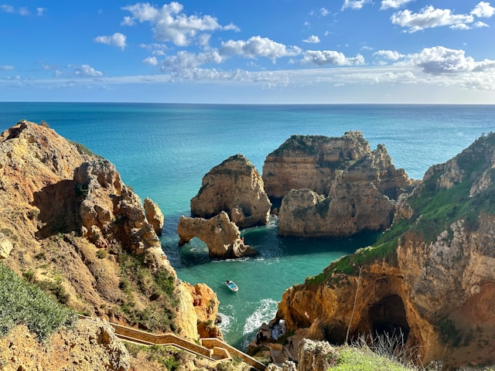
Algarve — Ponta da Piedade cliffs and turquoise coves near Lagos
Most visitors to the Algarve see one stretch of it — usually whichever beach is closest to their hotel. This trip moves along the western coast, mixing the famous cliffs with the quieter coves on either side. Mornings are walks; afternoons are free or on the water.
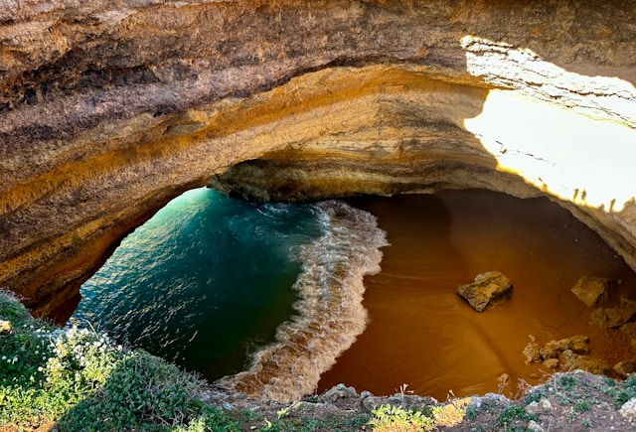
Benagil sea cave from the water
Day by day
- Day 1 — Arrive Lagos. Walking introduction to the old town and the slave market memorial. Welcome dinner on the harbour.
- Day 2 — Ponta da Piedade cliff walk (8 km, gentle, with stairs down to the cove). Boat trip in the afternoon to the sea caves.
- Day 3 — Drive west to Sagres. Walk to the Cape St Vincent lighthouse along the cliffs. Afternoon free in Sagres.
- Day 4 — Drive east to Tavira. Stop at the salt pans en route. Slow afternoon in Tavira’s old town.
- Day 5 — Ria Formosa lagoon by small boat: barrier islands, oyster beds, a swim if the weather agrees. Tour ends at Faro airport at 14:00.
What’s included. 4 nights’ accommodation (2 in Lagos, 1 in Sagres, 1 in Tavira), all guided walks, 2 boat trips, 3 dinners with wine, daily breakfast, all in-tour transport including airport drop-off.
What’s not. Flights, optional second sea-cave boat trip (€55), lunches.
Ideal for. First-time visitors to the Algarve. Travellers who want a coast trip without a hire car.
Departures 2026. Mar, Apr, May, Jun, Sep, Oct, Nov.
Single supplement. €260.

6 · Andalusia: Seville to Granada
8 days · Group of up to 12 · Difficulty 2 · From €2,190 per person
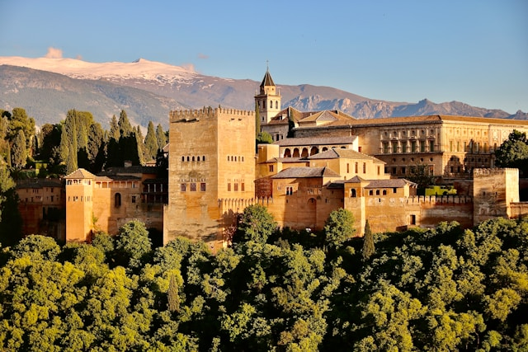
Granada — the Alhambra at sunset from Mirador San Nicolás
A longer trip and our only one that leaves Portugal. Three days in Seville, two in Córdoba, three in Granada — Moorish architecture, the cities they grew into, and the food that came out of all of it.
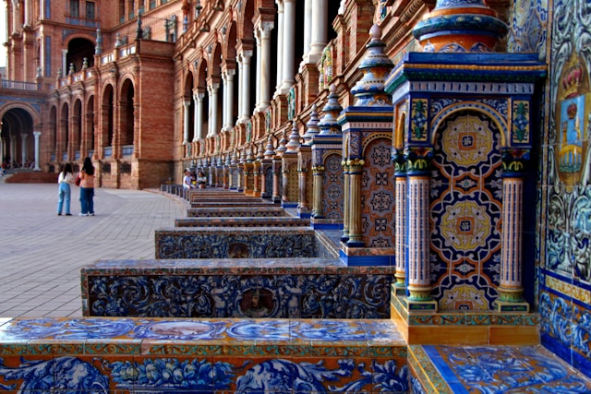
Seville — Plaza de España colonnade and tiled bridges
Day by day
- Day 1 — Arrive Seville. Evening walking tour of Santa Cruz. Welcome dinner with flamenco.
- Day 2 — Cathedral, Giralda, Royal Alcázar (skip-the-line entry). Free afternoon.
- Day 3 — Day trip to a sherry bodega in Jerez, or free day in Seville (your choice when booking).
- Day 4 — Train to Córdoba. Walking tour: the Mezquita, the Jewish quarter, the Roman bridge. Group dinner.
- Day 5 — Slow morning in Córdoba. Optional walking tour of the patios. Afternoon train to Granada.
- Day 6 — Alhambra and Generalife (full day with an art historian).
- Day 7 — Albaicín on foot. Sunset at Mirador San Nicolás. Farewell dinner in Sacromonte.
- Day 8 — Slow morning. Tour ends at 12:00 in central Granada.
What’s included. 7 nights’ accommodation in centrally-located three- and four-star hotels, all guided activities, Alhambra entrance with art historian, all train tickets between cities, 5 dinners with wine, daily breakfast.
What’s not. Flights, 2 dinners on free evenings, optional Jerez excursion (€85, if not selected as Day 3 main activity), Córdoba patio tour (€30).
Ideal for. Travellers with a week to spend and an interest in history, architecture, or food. Anyone who has already done a Lisbon or Porto trip with us.
Departures 2026. Apr, May, Sep, Oct.
Single supplement. €520.

7 · Sintra & Cascais Family Adventure
4 days · Group of up to 12 (children 8+) · Difficulty 1 · From €1,190 per person · From €690 per child (8-15)
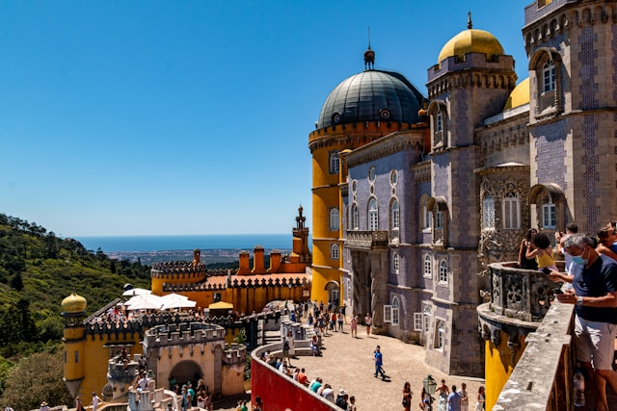
Sintra — Pena Palace, the colourful royal palace on its hilltop
Built for families with children aged 8 to 15. Shorter walking days, earlier dinners, two beach afternoons, and three castles that look like they were drawn for the trip.
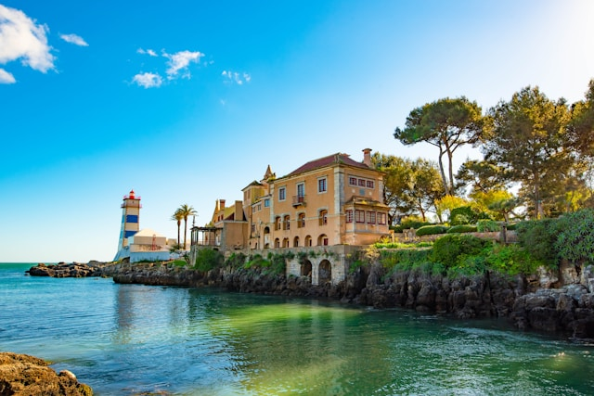
Cascais — sheltered beach and old town harbour
Day by day
- Day 1 — Pickup from Lisbon. Welcome lunch in Cascais. Beach afternoon and gelato in the old town.
- Day 2 — Sintra: Pena Palace (the colourful one) and the Moorish Castle. Walking pace adjusted for younger legs. Picnic lunch in the park.
- Day 3 — Quinta da Regaleira with its initiation well and underground tunnels — kids generally remember this for years. Free afternoon at the beach in Cascais.
- Day 4 — Cabo da Roca (the westernmost point of mainland Europe — children get a certificate). Lunch on the cliffs. Return to Lisbon. Tour ends at 16:00.
What’s included. 3 nights’ family-room accommodation in a Cascais hotel with a pool, all guided activities, 2 family dinners, picnic lunch on day 2, daily breakfast, all transfers from/to Lisbon, Regaleira and Pena entry tickets.
What’s not. Flights, 2 dinners on free evenings, additional snacks and lunches.
Ideal for. Families with children aged 8 to 15. Multi-generational groups (grandparents welcome).
Departures 2026. Apr, Jun, Jul, Aug, Oct.
Single supplement. Not applicable (family rooms).

Departures at a glance
All available departure months for 2026. Specific weeks confirmed at booking — please ask.
Tour | Available months
Lisbon Essentials | March, April, May, June, September, October, November
Porto & Douro Valley Explorer | April, May, June, September, October
Azores: São Miguel Hiker | May, June, September
Alentejo Wine Trail | April, May, September, October
Algarve Coast in 5 Days | March, April, May, June, September, October, November
Andalusia: Seville to Granada | April, May, September, October
Sintra & Cascais Family Adventure | April, June, July, August, October

By month
- March — Lisbon Essentials, Algarve Coast in 5 Days.
- April — Lisbon Essentials, Porto & Douro Valley Explorer, Alentejo Wine Trail, Algarve Coast in 5 Days, Andalusia: Seville to Granada, Sintra & Cascais Family Adventure.
- May — Lisbon Essentials, Porto & Douro Valley Explorer, Azores: São Miguel Hiker, Alentejo Wine Trail, Algarve Coast in 5 Days, Andalusia: Seville to Granada.
- June — Lisbon Essentials, Porto & Douro Valley Explorer, Azores: São Miguel Hiker, Algarve Coast in 5 Days, Sintra & Cascais Family Adventure.
- July — Sintra & Cascais Family Adventure.
- August — Sintra & Cascais Family Adventure.
- September — Lisbon Essentials, Porto & Douro Valley Explorer, Azores: São Miguel Hiker, Alentejo Wine Trail, Algarve Coast in 5 Days, Andalusia: Seville to Granada.
- October — Lisbon Essentials, Porto & Douro Valley Explorer, Alentejo Wine Trail, Algarve Coast in 5 Days, Andalusia: Seville to Granada, Sintra & Cascais Family Adventure.
- November — Lisbon Essentials, Algarve Coast in 5 Days.
We don’t run tours in December, January, or February.

Talking to us
Email hello@wanderlusttours.example Phone +351 21 000 0000 (Mon–Fri, 09:00–18:00 Lisbon time) Office Rua das Flores 88, 1200-194 Lisbon — visits by appointment
For booking enquiries, the fastest reply is by email. We aim to respond within one working day.
For changes to a confirmed booking, please ring the office.
For anything urgent during a tour, your guide’s number is in your pre-departure pack.

Last updated 2026. Prices in euros, per person sharing a twin or double, unless noted. Itineraries are subject to small adjustments — weather, operating hours, the occasional festival.

