Pulteney Art House — Current Exhibitions
What’s on now and what’s coming next

We run two to three major exhibitions a year, typically drawing on our own permanent collection and bringing in loans from public and private collections across the UK and Europe. Each exhibition is in our purpose-built temporary exhibition wing and is included with general admission unless noted.
For background on the artists, periods, or movements that any of these exhibitions touches on, our website assistant can look up public information — ask about an artist by name.

On now

Northern Light: Dutch Painting in the Golden Age
5 February — 28 June 2026 · Included with admission
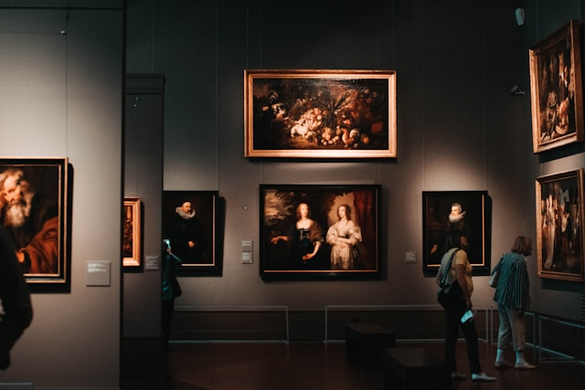
Northern Light exhibition — installation view of the main gallery
A focused exhibition of Dutch seventeenth-century painting, built around the eleven works in our permanent collection and supplemented by twenty-six loans from regional museums in the UK and the Netherlands. The exhibition foregrounds painters working outside the major studios — provincial portraitists, marine specialists from the Zuiderzee ports, and the genre painters of Leiden and Delft whose names are less familiar than Vermeer or Rembrandt but whose work shaped what we now think of as the Golden Age.
Featured artists. Pieter de Hooch, Gerard ter Borch, Gabriel Metsu, Jan van Goyen, Aelbert Cuyp, Judith Leyster, Adriaen van Ostade, Frans van Mieris, Gerrit Dou, Salomon van Ruysdael, and a small group of Delft school painters.
Three rooms. Room I — Light and Domesticity (de Hooch, ter Borch, Metsu, Leyster). Room II — Land and Sea (van Goyen, Cuyp, the marine painters). Room III — Trade and Daily Life (van Ostade, Dou, Mieris, the Delft school).
Audio guide. Free for visitors with their own headphones — download from our website on arrival.
Curator’s tour. Wednesdays at 11:30 and the first Saturday of each month at 14:00. No booking required.

Cabinet of Curiosities: The Edwardian Collector
14 March — 30 August 2026 · Included with admission
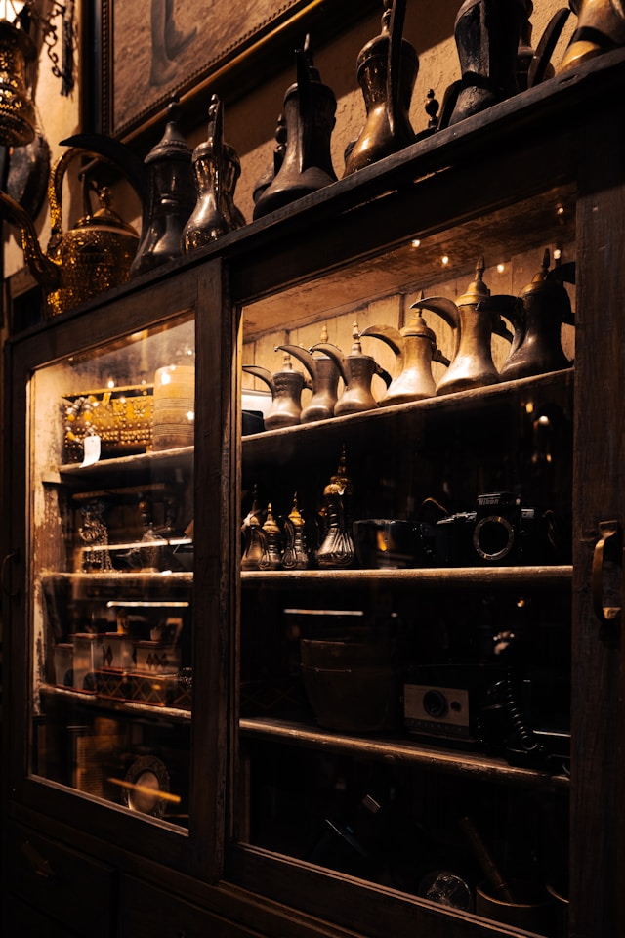
Cabinet of Curiosities — close view of a wall-mounted cabinet of small objects
A smaller, more intimate exhibition in our first-floor reading room. The decades around 1900 were a quietly intense period for private collecting in England — provincial enthusiasts assembling cabinets of antiquities, shells, fossils, coins, miniatures, and small bronzes, often displayed together in a single room as a curiosity cabinet in the older eighteenth-century mode. Elenor Caversham, our founder, was one of these collectors, and many of the small objects in our permanent collection were arranged exactly this way during her lifetime.
This exhibition reassembles a speculative Edwardian cabinet from across our holdings — Roman intaglios, Renaissance bronzes, Wedgwood medallions, snuffboxes, miniature portraits, a small Egyptian shabti, and a collection of natural-history objects loaned from a private collection in Wiltshire.
Featured artists and makers. Josiah Wedgwood, Richard Cosway, Andrea Riccio, an anonymous Roman gem-cutter, an anonymous Egyptian craftsman of the New Kingdom, John Smart, and several unnamed eighteenth- and nineteenth-century jewellers and snuffbox makers.
For families. A printed scavenger-hunt card is available at the entrance to the exhibition. Children find seven objects across the cabinet; those who find them all receive a small print of a Wedgwood medallion at the front desk.

Coming soon

Mary Cassatt: At Home and Among Friends
11 September 2026 — 24 January 2027 · Free entry day on opening Sunday
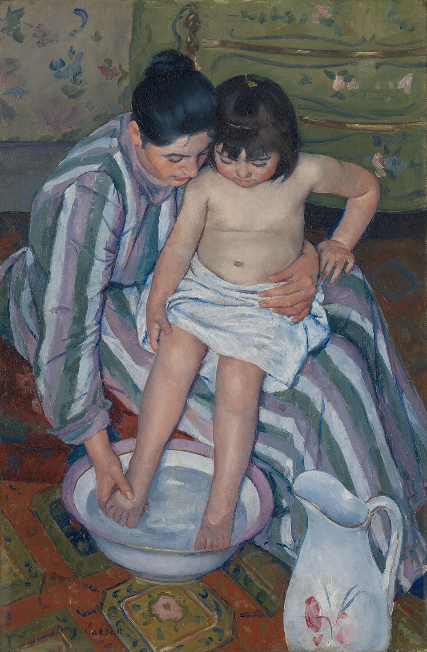
Mary Cassatt — preview banner showing one of the works in the exhibition
Our autumn exhibition. Thirty-eight works by Mary Cassatt — paintings, pastels, and her late prints — drawn from a single private American collection that has rarely been seen in Europe. Cassatt spent most of her life in France, working alongside Degas and the Impressionists, but the works in this collection focus on her depictions of domestic life: mothers and children, women reading, friends at tea. It is, deliberately, the quieter Cassatt.
Featured artist. Mary Cassatt (1844–1926).
Why this exhibition. The loan was offered to us by a long-standing patron of the museum who has studied Cassatt’s later work for thirty years; the show was developed to mark the 180th anniversary of her birth. Many of the works have not been publicly exhibited since the 1970s.
Ticketed for non-members on weekends. During this exhibition, weekend admission is by timed ticket only, to keep the galleries comfortable. Members visit any time without booking.
Free entry on opening Sunday. Sunday 13 September will be a free-admission day. The exhibition will be busy — quietest hours are typically 10:00–11:30.

In the planning stage
We’re currently developing two further exhibitions for 2027:
- Spring 2027. Silver from the Long Eighteenth Century — a focused look at English silver from the 1770s and 1780s, including six loans from a major national collection.
- Autumn 2027. A title-pending exhibition on portraits of women writers of the eighteenth century, in partnership with a country-house museum in Hampshire.
Dates and details are subject to change. We announce confirmed exhibitions about six months in advance.

How to get the most out of an exhibition visit
A few suggestions if you’ve come specifically for an exhibition rather than the permanent collection:
- Read the introduction panel. Each exhibition begins with a short panel that frames the works — usually two to three paragraphs. It’s the single most useful thing in the room.
- Don’t try to see everything. Pick three or four works to spend real time with, and walk past the others. Most people remember more from a slow visit than a thorough one.
- Ask the room steward. Our stewards aren’t just there to watch the work — they know the exhibitions in depth and are happy to talk.
- Use the assistant. Our website assistant can give you background on any artist in any of our exhibitions — it pulls information from public sources at the time you ask, so it’s a quick way to get context on an unfamiliar name. Try asking before your visit or while you’re here.

Past exhibitions
A short list of recent exhibitions, in case you remember one you’d like to know more about. Catalogues for most are still available in the shop or by mail order.
Exhibition | Dates
Renaissance Bronze: Italian Sculpture at Small Scale | Sep 2025 – Jan 2026
Bath Pavements: Watercolour and Topography 1780–1830 | Apr – Aug 2025
Wedgwood and the Classical Tradition | Oct 2024 – Feb 2025
British Portrait Miniatures from a Private Collection | Mar – Jul 2024
The Dutch Italianates | Sep 2023 – Feb 2024
For exhibitions older than the list above, our archive is searchable on the website.

Practical notes
Opening times during exhibitions. Standard hours — Tuesday to Sunday, 10:00–17:00. The exhibition wing closes 15 minutes before the rest of the museum to allow stewards to clear the space.
Photography in exhibitions. Loan works are not always photographable — this varies by lender. Look for the small camera-icon labels: a camera with no line through it means photography is permitted (no flash, personal use only); a camera with a line through it means no photography. If in doubt, ask the steward.
Late evening openings. Each major exhibition has one late-evening opening (until 21:00) about three weeks after it opens. These are free for members. Non-members can buy a discounted ticket (£8.00). Drinks served in the reading room.
Catalogues. Each major exhibition has a printed catalogue available in the shop, usually £20–£25, with member’s discount applied. Catalogues are also available by mail order — contact shop@pulteneyarthouse.example.

Exhibitions information last updated for 2026. Dates and details may change — please check the website or contact us before a long journey. Visitor enquiries: hello@pulteneyarthouse.example · +44 1225 000 000.
Disclaimer: Pulteney Art House and the supporting materials in this document are fictional and created solely for demonstration purposes. The artists mentioned in this document are real public-domain historical figures, but their inclusion in the exhibitions described here is a fictional curatorial scenario. Any resemblance of the institution or supporting details to real organisations is unintended.

